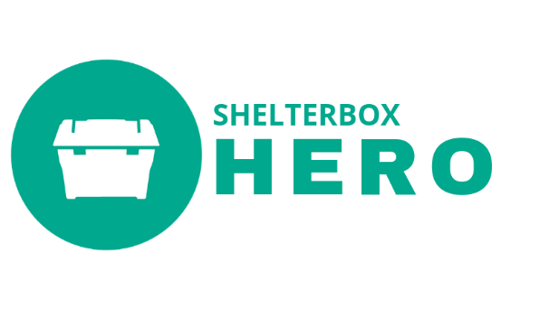
ShelterBox USA – HERO Program Q&A

Under the new program, how do Clubs qualify as a HERO Club?
ShelterBox USA is now awarding the HERO designation to Clubs when a Club donates $1,000, $3,000, or $5,000 HERO gift within a single Rotary Year.

When is the new program effective?
July 1st 2019

How will Clubs be recognized?
When a club donates $1000, $3000, or $5000 as a HERO gift within a Rotary Year they will receive a certificate and a HERO digital badge for their website.
Upon the third year of consecutive giving, Clubs will receive a banner reflective of their giving level.

Upon the 10th year of consecutive giving, special recognition will be ordered.

Recognition will be generated from SBUSA.
- SBUSA staff will prepare custom HERO recognition end of February – early March.
  - By district, Ambassadors will be notified of qualifying Clubs. Ambassadors will be given the option to receive a District Recognition Package that includes certificates and banners for qualifying clubs.
  - If Ambassadors opt out of mailing or there is no Ambassador present, the District Recognition Package will be sent to the District Governor Elect
- District Recognition Packages will be shipped to Ambassadors in March and to DGEs by the end of June (first year, June 2020)

The preferred method of recognition is at your District Conference, on stage personally recognizing each HERO Club.

When this is not possible, we encourage Ambassadors to set up a ShelterBox Happy Hour during District Conference to recognize HERO Clubs.

Other District Conference options
- Work with the DisCon Committee to get a page in the District Conference Program where HERO Clubs can be listed.
- Give Certificates out at and recognize Clubs at your ShelterBox booth
- Create a “Thank You HERO Clubs” Poster, listing all HERO Clubs, to have printed and displayed at your ShelterBox booth

What has not changed?
- Our need for support and sustainable giving to ensure we are prepared for the next disaster. A ShelterBox HERO is still considered a Rotary Club who has committed to making an ongoing impact in worldwide disaster response by supporting ShelterBox.

The HERO program was designed and remains a way for ShelterBox to stay prepared for upcoming disasters in several ways. Natural and other disasters are inevitable and frequent, and the need is continuous. It takes time for items to be purchased or manufactured before being packed and, by pre-packing aid, it is ready to go when needed. ShelterBox HERO Clubs allow us the resources and time to be ready when disaster strikes.
- HERO Giving Levels:
- Bronze $1,000
- Silver $3,000
- Gold $5,000

- Our Ambassadors ability to personally celebrate HERO Clubs and steward these important relationships.

What has changed?
- We will now be recognizing clubs annually instead of with a 3-year pledge or after 3-years of consecutive giving.

- We will no longer be requiring pledges.

- We ask that all gifts specifically state “HERO Gift” on the check or accompanied note. To keep the integrity of the HERO program, we now ask that all gifts are specially marked for HERO designation. In recent years, ShelterBox USA has been retroactively acknowledging Clubs with a 3-year consecutive giving history for any gifts at $1,000, $3,000, or $5,000 regardless of the designation. In our new program, we ask that gifts specify “HERO.” This gift will be specially allocated to our HERO program while any other donations will be on-top of the HERO program giving. For example, should disaster strike and you are lead to donate, this donation would not count toward your HERO gift.

- We have created a timeline* that coincides with the Rotary Year. Customized HERO Recognition will now be going out one-time a year as stated above.

For Ambassadors who have upcoming presentations, who want to present a token of appreciation to supporting Clubs, ShelterBox USA will have a “ShelterBox Supporter” certificate available.

What is the timeline*?
July SBUSA mails out New Rotary Year letters.
In 2019, 3 different types of letters will be mailed out:
- Letter for Non-Giving Clubs to introduce new program. Inviting clubs to be HEROs.
- Letter for Clubs who have given consecutively to thank for on-going support and explain changes to HERO Program. This letter will recognize their previous HERO level giving and invite Clubs into our new program.
- Letter for Clubs who have recently pledged. This letter will thank Clubs for their recent commitment, explain the new program, and let them know we look forward to their future gift.
January SBUSA will send another batch of letters:
- A Letter addressing Clubs who have given and letting them know how close they are to the next level
- A letter addressing Clubs who have not given at all and letting them know there is still time.
Late February SBUSA staff will prepare custom HERO recognition.
- By district, Ambassadors will be notified of qualifying Clubs. Ambassadors will be given the option to receive a District Recognition Package that includes certificates and banners for qualifying clubs.
- If Ambassadors opt out of mailing or there is no Ambassador present, the District Recognition Package will be sent to the District Governor Elect

March District Recognition Packages shipped out to Ambassadors
April – June+ Ambassadors are distributing at District Conference or visiting Clubs to present
June District Recognition Packages will be shipped to DGEs whose district was not covered for recognition
- Packet will include letter asking DGE to distribute certificates to club during their upcoming Rotary Road Show

What happens to the Clubs who have recently pledged?
SBUSA is preparing specialized communication to these clubs. A letter will go out in July to thank them for their willingness to commit, explain the changes to the program, and letting them know we look forward to their gift. They will keep any prior recognition given and receive the appropriate recognition under the new program as outlined above.

What about Clubs who give every year, but haven’t been officially a part of the HERO program (Clubs we’ve retroactively acknowledged as HEROs)?
SBUSA is preparing specialized communication to these clubs. A letter will go out in July to thank them for their on-going support. We will explain the changes to our HERO program and advise that all future gifts must specify “HERO” in order to qualify. We will invite them to participate in our new program.

